Year 11 Chemistry
AECHE
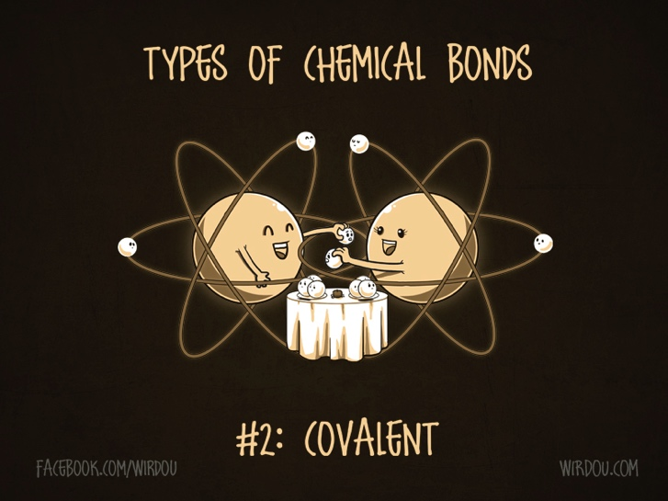
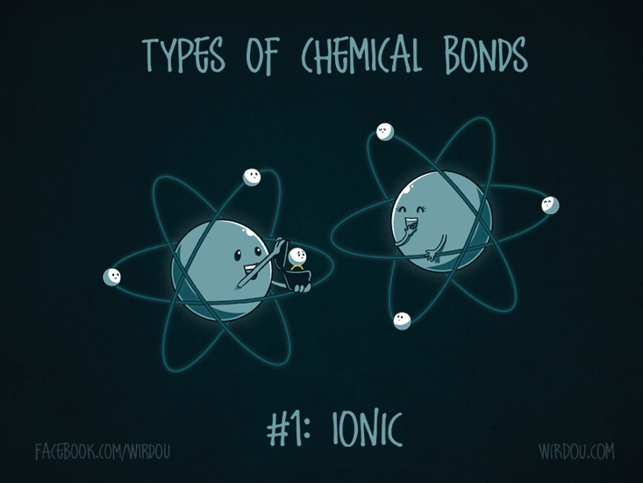

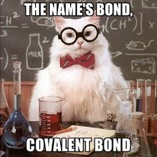

Bonding

Chemical bonds are caused by electrostatic attractions that arise because of the sharing or transfer of electrons between participating atoms; the valency is a measure of the bonding capacity of an atom .

BONDING

- Essentially, chemical bonds are the force holding atoms, ions or molecules together.
- The forces are electrostatic - a balance of the attraction of oppositely charge particles and the repulsion of similarly charged particles.
- The types of bonds formed depend on the outer electron configuration of atoms and the nature of the atoms which are being bonded.

- The structure of a substance depends on:
i. the nature of the particles present. ii. the force holding the particles together.

- Bonding that occurs inside substances is due to INTRAMOLECULAR FORCES.

- Elements can be classified into 4 groups:

i. metals,
ii. covalent molecular substances,
iii. covalent network elements.
iv. ionic substances

- Melting points of most non-metal elements and most compounds tend to be low - exceptions include: carbon and silicon, SiC and SiO₂.

- Metallic elements have a wide range of melting points, but they are generally high. Compounds formed between metals and non-metals have high melting points.

NC p160-2 QS 3.1 p162

Metallic bonding can be modelled as a regular arrangement of atoms with electrostatic forces of attraction between the nuclei of these atoms and their delocalised electrons that are able to move within the three dimensional lattice.

Metallic Bonding
- Chemists have devised a model about the structure of metals:
i. the outermost or valence electrons in metal atoms move about freely with in a three-dimensional arrangement or lattice of positively charged metal ions.
ii. consists of positive ions surrounded by a ‘sea’ of electrons.
iii. valance electrons are delocalised - they are not associated with a particular metal ion and move through the lattice of metal ions. The number of electrons that are removed from each atom is related to the valence of the atom.
  - the negatively charged electrons are attracted to the positively charged metal ions in the lattice and this electrostatic attraction holds the lattice together - metallic bonding.
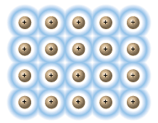

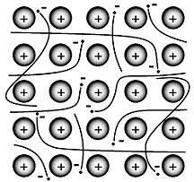

The metallic bonding model can be used to explain the properties of metals, including malleability, thermal conductivity, generally high melting point and electrical conductivity

Metallic Properties
- All metallic substances tend to be solid at room temperature; with exception of liquid mercury.
- Physical characteristics (properties) that all metals share include:
- good conductors of electricity

  - Metals conduct electricity because of the mobility of the electrons within the lattice.
  - Electrons entering one end of the metal cause a similar number of electrons to displaced from the other end and the metal conducts.
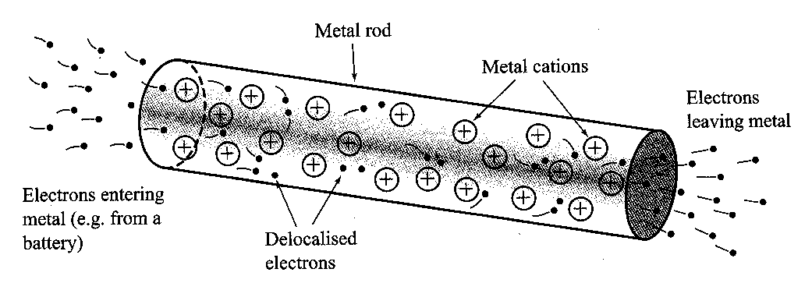

- good conductors of heat

- Metals contain delocalised electrons: electrons which are not associated with a particular metal ion and move through the lattice of metal ions - these mobile electrons acquire heat from a heat source and rapidly transfer it to cooler parts of the lattice.

- have shiny surface when freshly cut or cleaned (lustre)
- malleable and ductile

- Because the delocalised electrons do not belong to any particular atom, if enough force is applied, one layer of atoms can slide over another layer without disrupting the metallic bonding.
- Metals are malleable – they can be easily bent without breaking. This is because the delocalised electrons are not attached to one particular atom and the forces of attraction between the electrons and the positive ion are said to be non-directional. Any stress on the metal can push it out of shape but the very strong forces of attraction still exist.


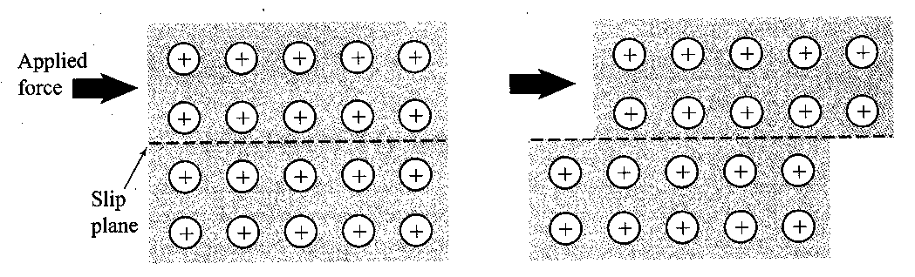

- relatively high melting points.

- Metals have high melting and boiling points due to strong electrostatic attraction between the positive metal ions and the delocalised electrons.
- Group II of the periodic table form the strongest metallic bonds because they tend to form di-positive metal ions and lose two electrons per atom.

- relatively dense solids.

- The above physical characteristics have enabled scientists to make a number of inferences about the metals:
i. The high densities indicate that the atoms are packed tightly together.
ii. Malleability and ductility indicates that there is only limited resistance to movement of atoms with respect to each other.
iii. Electrical conductivity indicates that metal contain mobile charged particles.

Uses of Metals
i. Aluminium - used in domestic utensils, drinks cans, cooking foil etc. Used due to its thermal conductivity, malleability and attractive lustre.
ii. Copper - electrical wiring; excellent conductors of electricity.

PROBLEM SET #1:

- For an element to be a metal what is the major characteristic of the valence electrons of the element?

- List four properties of metals and show how these properties can be explained in terms of the ‘delocalised electrons’ model of metallic bonding.

- Mercury has a melting point of -38.9 ºC and tungsten has a melting point of 3410 ºC. What does this indicate about the metallic bond?

- Explain why:
- copper is used in wiring a house
- titanium is used in the production of airplanes.

NC p163-4 QS 3.2 p167
EC p54 Set 10

IONIC COMPOUNDS

- The basic particles which make up ionic compounds are ions: electrically charged atoms which have lost or gained electrons.

Ions are atoms or groups of atoms that are electrically charged due to a loss or gain of electrons; ions are represented by formulae which include the number of constituent atoms and the charge of the ion
(for example, O^{2–}, SO₄^{2–}).

Simple Ions
- Cations - positively charged atoms which are formed when one or more electrons are removed from an atom.
- Anions - negatively charged atoms which are formed when one or more electrons are gained by an atom.

- Elements that are cations are metallic elements - exception hydrogen and ammonium. Anions are non-metal atoms.

Polyatomic Ions
- Polyatomic ions are groups of atoms bonded to one another which have a net positive or negative charged.

- Examples include: phosphate, PO₄³⁻, carbonate CO₃²⁻, ammonium NH₄⁺.

- The types of bonds holding the atoms within the polyatomic ion together are chemical bonds similar to those involved in molecules (i.e. covalent bonds).

The formulae of ionic compounds can be determined from the charges on the relevant ions.

Writing formulae for ionic compounds

- Ionic compounds are electrically neutral.
- Total positive charge must equal total negative charge.
  - Sodium chloride
  - Na⁺ has a +1 charge, Cl⁻ has a -1 charge.
  - A crystal of sodium chloride has the ratio of Na to Cl as 1:1 – NaCl.
  - Magnesium chloride
  - Mg²⁺ has a +2 charge, Cl⁻ has a -1 charge.
  - A crystal of magnesium chloride needs two chlorines for each magnesium and has the ratio of Mg to Cl as 1:2 – MgCl₂.

- The system used for naming ionic compounds:

i. The name of the positive ion is written first.
ii. The name of the negative ion is written second and ends in –ide.
iii. Where the ionic compound has water molecules of crystallisation, the number of water molecules is indicated.

- Example: Sodium carbonate-10-water = Na₂CO₃.10H₂O

- Students should be able to recognise and write the formula of the following ions and molecules:

Ion name | Formula |  | Ion name | Formula
ammonium | $${NH}_{4}^{+}$$ |  | bromide | $${Br}^{-}$$
caesium | $${Cs}^{+}$$ |  | chloride | $${Cl}^{-}$$
hydrogen | $$H^{+}$$ |  | cyanide | $${CN}^{-}$$
lithium | $${Li}^{+}$$ |  | dihydrogenphosphate | $$H_{2}{PO}_{4}^{-}$$
potassium | $$K^{+}$$ |  | ethanoate (acetate) | $${CH}_{3}{COO}_{}^{-}$$
rubidium | $${Rb}^{+}$$ |  | fluoride | $$F^{-}$$
silver | $${Ag}^{+}$$ |  | hydrogencarbonate | $${HCO}_{3}^{-}$$
sodium | $${Na}^{+}$$ |  | hydrogensulfate | $${HSO}_{4}^{-}$$
barium | $${Ba}^{2+}$$ |  | hydroxide | $${OH}^{-}$$
calcium | $${Ca}^{2+}$$ |  | iodide | $$I^{-}$$
cobalt(II) | $${Co}^{2+}$$ |  | nitrate | $${NO}_{3}^{-}$$
copper(II) | $${Cu}^{2+}$$ |  | nitrite | $${NO}_{2}^{-}$$
iron(II) | $${Fe}^{2+}$$ |  | permanganate | $${MnO}_{4}^{-}$$
lead(II) | $${Pb}^{2+}$$ |  | carbonate | $${CO}_{3}^{2-}$$
magnesium | $${Mg}^{2+}$$ |  | chromate | $${CrO}_{4}^{2-}$$
manganese(II) | $${Mn}^{2+}$$ |  | dichromate | $${Cr}_{2}O_{7}^{2-}$$
nickel(II) | $${Ni}^{2+}$$ |  | hydrogenphosphate | $${HPO}_{4}^{2-}$$
strontium | $${Sr}^{2+}$$ |  | oxalate | $$C_{2}O_{4}^{2-}$$
zinc | $${Zn}^{2+}$$ |  | oxide | $$O^{2-}$$
aluminium | $${Al}^{3+}$$ |  | sulfate | $${SO}_{4}^{2-}$$
chromium(III) | $${Cr}^{3+}$$ |  | sulfide | $$S^{2-}$$
iron(III) | $${Fe}^{3+}$$ |  | sulfite | $${SO}_{3}^{2-}$$
 |  |  | nitride | $$N_{}^{3-}$$
 |  |  | phosphate | $${PO}_{4}^{3-}$$

- Write the ionic formula for the following:

potassium chloride ______________ lead oxide ______________

sodium sulphate ______________ aluminium oxide ______________

nickel hydrogen phosphate ______________ iron (III) oxalte ______________

- Name the following ionic compounds:

Na₂SO₃ ____________________ Al₂(Cr₂O₇)₃ ____________________

CrN ____________________ (NH₄)₂CO₃ ____________________

CuNO₂ ____________________ NaHSO₄ ____________________

- The structure of an ionic solid can be best described by using an example such as sodium chloride:

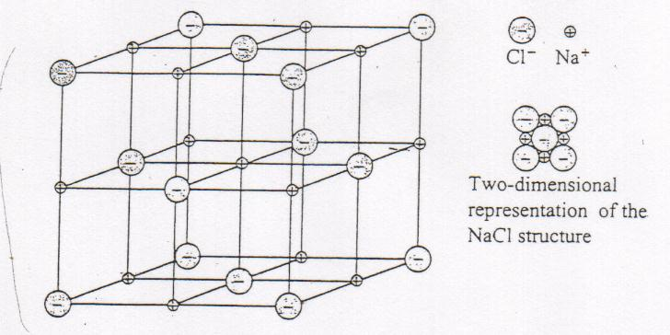
i. ions in the crystal are arranged in a regular three-dimensional lattice.
ii. each sodium ion is surrounded by six negative chloride ions and each negative chloride ion is surrounded by six positive sodium ions.
iii. when a solid, the position of the ions is fixed.

- In ionic solids ions are held in the crystal lattice by strong electrostatic attraction to the oppositely charged ion around it - called ionic bonding.

- Ionic compounds form between metal and non-metal elements. All substances formed when metals from groups I and II of the periodic table react with non-metals from groups VI and VII are ionic compounds.

NC p168-170
Ionic bonding can be modelled as a regular arrangement of positively and negatively charged ions in a crystalline lattice with electrostatic forces of attraction between oppositely charged ions.

Formation of Ionic Compounds

- An ionic compound forms when a metal and a non-metal element react. During this reaction the metal atoms lose electrons to form positive ions and the non-metal atoms gain electrons to form negative ions.

- Ionic compounds are generally formed between two atoms that have a large difference in their electronegativity. An atom like Na has a low electronegativity and will not attract electrons. Cl has a high electronegativity and strongly attracts electron.

- In this exchange of electrons, both metal and non-metal atoms achieve a noble gas electron configuration (octet rule).

- Take NaCl as an example:
- Na (2,8,1) lose one electron to become Na⁺ (2,8) ; same e⁻ configuration as Ne (noble gas)
- Cl (2,8,7) acquires an electron to become Cl⁻ (2,8,8) ; same e⁻ configuration as Ar (noble gas)

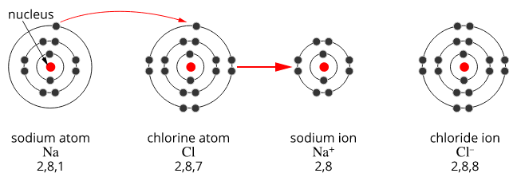
NC p171-2
The ionic bonding model can be used to explain the properties of ionic compounds, including high melting point, brittleness and non-conductivity in the solid state; the ability of ionic compounds to conduct electricity when molten or in aqueous solution can be explained by the breaking of the bonds in the lattice to give mobile ions.

Properties of Ionic Compounds

- The physical properties of ionic compounds are:
- Hard and brittle

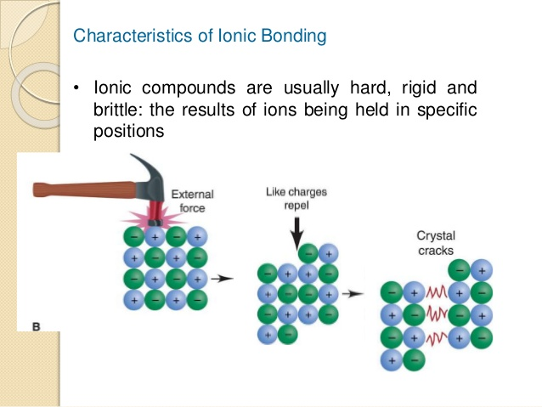
- Strong attractive force exists between oppositely charged ions; if a layer of crystal is forced to slide past another layer, the orderly arrangement of ions is disturbed. Ions of similar charge are forced closer to another with an increase in repulsive forces and decrease in attractive forces - the crystal fractures.

- This makes ionic compounds:
i. hard
ii. brittle, and
iii. difficult to cut


- Non-conductors of electricity in the solid state, but good conductors when molten or in aqueous solution.

- An ionic solid does not conduct electricity; the ions are in fixed positions and can not move. However, molten ionic compounds and ionic compounds dissolved in water conduct electricity because the ions are free to move. They do not conduct electricity as well as metals.
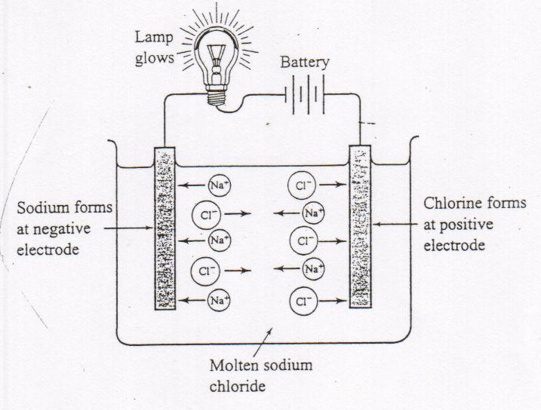

- The conductivity of molten ionic compounds suggests that ionic substance contain positively charged metal ions and negatively charged non-metal ions. Particles which are free to move when in the molten state.


- High melting and boiling points.

- Strong electrostatic forces of attraction extend throughout lattice keeping ions in fixed positions, high temperature needed to disrupt bonds.

- Solubilities in water vary but they are not soluble in non-polar solvents like oil.

NC p173-4

PROBLEM SET #2:

Why will a magnesium sulphate crystal shatter when you hit it with a hammer but magnesium will not? Explain fully. (Use diagrams to assist you)

NC p174 QS 3.3
EC p56 Set 11

Electron dot diagrams of Ionic Compounds

- Electron dot diagrams are a simple way of showing the arrangements of valence electrons around atoms and the changes that occur as atoms react with each other.

- Draw the electron dot diagrams for the following atoms:

H Na Mg Cl O

- Electron dot diagrams can be used to represent the formation of ions in ionic bonds eg.
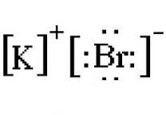
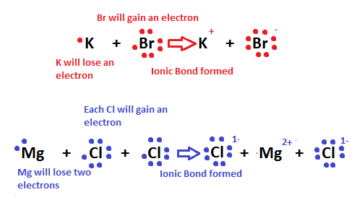

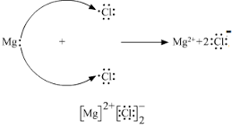

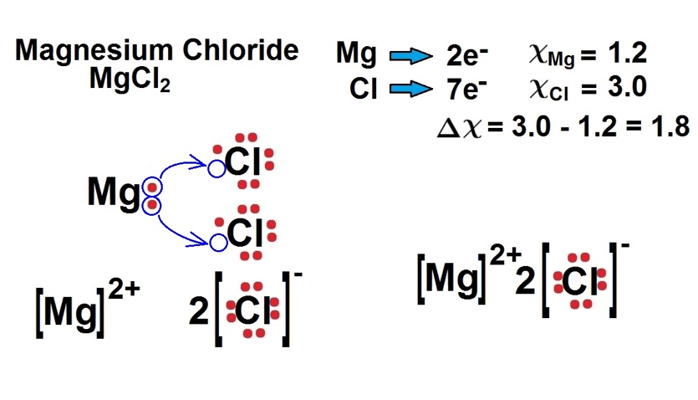

- Draw the electron dot diagrams of the following:
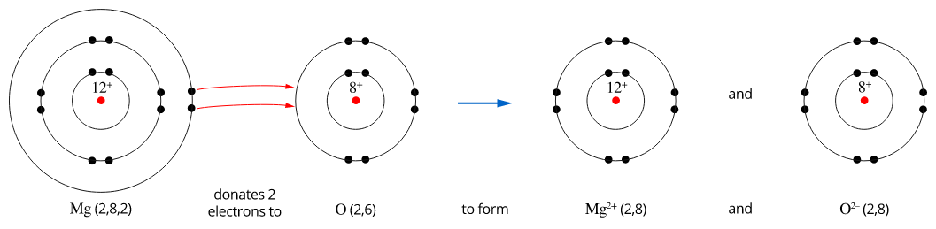
Magnesium oxide:

Aluminium oxide:

Calcium Iodide

PROBLEM SET #3:

Predicting the elements in an ionic compound

- Only consider the elements which gain or lose electrons to become like the Noble Gases for these questions.
- From a formula of an ionic compound you can work out what the possible charges are on the pair of ions.
- For example P₂Q tells us that P is positively charged (because it is written first) and its charge is HALF the value of the negative charge on Q (the one written second). So P could be +1 and Q be -2, this would give a formula P₂Q. But P could also be +2 with Q -4, this would also give P₂Q.

  - If we have a formula PQ₃ and the electronic configuration of both ions is 2,8 then what are the possible identities of P and Q?

  - If the formula of a simple salt made up of just two elements is JX₂ and the ions have the same electron population of Argon then what are the possible identities of J and X?

  - Krypton has the same electron configuration as both ions in an ionic substance whose identity is hidden in a general formula ZD. What are THREE possible element combinations that agree with this formula ratio?

  - What is the identity of the two elements in ionic substance RA₃ where the metallic element is like neon in its electronic configuration and the non-metal ion is like Krypton?

  - What is the identity of the elements in GL if the cation has electron population 2 8 8 and the element L has electron population 2 8 6 ?

6. Explain why in potassium chloride there must be the same number of potassium ions and chloride ions whereas in magnesium chloride there are twice as many chloride ions as magnesium ions.

NC p177 QS 3.4
Covalent bonding can be modelled as the sharing of pairs of electrons resulting in electrostatic forces of attraction between the shared electrons and the nuclei of adjacent atoms.

COVALENT COMPOUNDS

- Covalent bond - occurs when non-metal atoms in a molecule share electrons and is held together by the directional electrostatic attraction between the shared electrons and the nuclei of adjacent atoms.

- Covalent bonds are formed between atoms that have similar electronegativities. No atom is strong enough to pull away the electrons in a bond so they are shared.

- Covalent compounds are divided into two different groups:
- Covalent molecular substances
- Covalent network substances
The properties of covalent molecular substances, including low melting point, can be explained by their structure and the weak intermolecular forces between molecules; their non-conductivity in the solid and liquid/molten states can be explained by the absence of mobile charged particles in their molecular structure.

Covalent molecular substances

- Many elements exist in nature as simple molecules. A molecule is a group of two or more atoms held together by chemical bonds. Some elements which exist as molecules include:

Hydrogen gas - H₂
Oxygen gas - O₂
Nitrogen - N₂
Fluorine - F₂

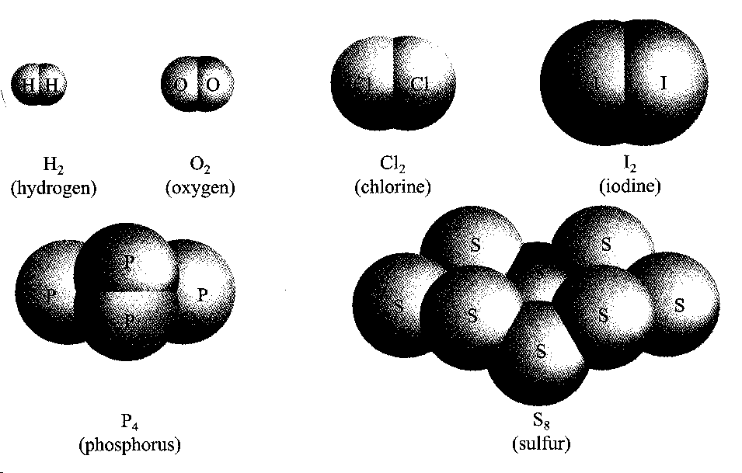

- These are diatomic molecules: molecules which consist of two atoms bonded together.
- Other non-metal elements exist as polyatomic molecules: consist of several atoms bonded together in the molecule. Examples include - phosphorous, P₄, and sulphur, S₈.


Example: Hydrogen gas

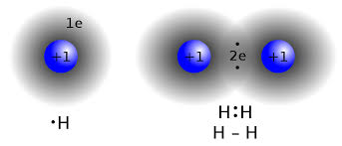

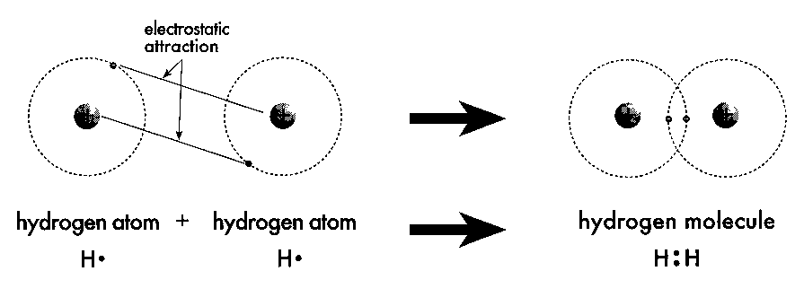

i. both hydrogen atoms have an electron configuration of 1s¹ or (1).
ii. both need one electron to attain the electron configuration of helium.
iii. both have the same ionisation energies so electron transfer can not occur.
iv. instead each H atom shares it single 1s¹ electron - each atom has the stable electron configuration of He.

- Noble gases exist as simple atoms since all the orbitals of are fully occupied, so no covalent bond formation is possible.

- Examples of molecules and noble gas atoms:
Name | Formula | Name | Formula
Argon  Bromine  Chlorine  Helium  Hydrogen  Fluorine  Iodine | Ar  Br₂  Cl₂  He  H₂  F₂  I₂ | Krypton  Neon  Nitrogen  Oxygen  Ozone  Phosphorous  Sulphur | Kr  Ne  N₂  O₂  O₃  P₄  S₈

Properties of Covalent Compounds

- Covalent molecular substances have the following properties in common:

- They have low melting points and boiling points – many are liquids or gases at room temperature.
- They are non-conductors of electricity in both solid and liquid states.
- They form solids which are generally quite soft and often have a waxy appearance.
- Tend to be malleable rather than shatter.
- They exist as molecules.
- Many are insoluble in water but soluble in non-polar solvents like petrol.
- Many have an odour.

PROBLEM SET #4:
- Why does a covalent molecular substance not conduct electricity?

- Why does sulphur (S₈) melt at 115.2 °C and carborundum (SiC) at 2730 °C? Explain fully.

- Name four properties of covalent network substances.

NC p185 QS 3.5
STAWA pg.139-141 Set 14-16
Names and formulae of Covalent Molecular Substances

In covalent molecular compounds the formula represents the number of atoms of each element in one molecule of the compound:

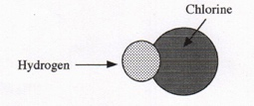
i. hydrogen chloride:
HCl - contain 1 atoms of hydrogen and 1 atom of chlorine.

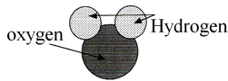
ii. water:
H₂O - contains 2 atoms of hydrogen and 1 atom of oxygen
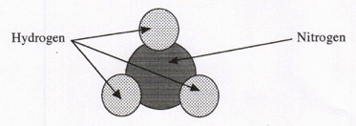
iii. ammonia:
NH₃ - contains 1 atom of nitrogen and 3 atoms of hydrogen

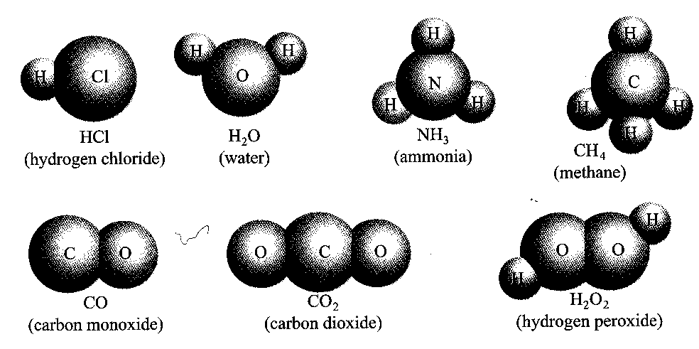

The procedure used to name molecular compounds:
- The name of the elements closer to the bottom or left hand-side of the periodic table is written first.
- The second part of the name is obtained by adding the suffix, ‘ide’, to the stem of the name of the second element.
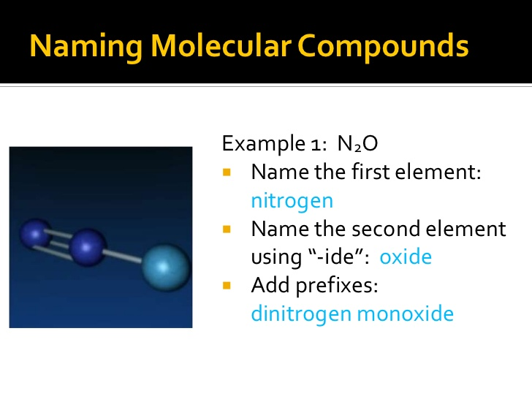
- Where a molecule contains more than one atoms of one type the number of atoms is indicated by a prefix:
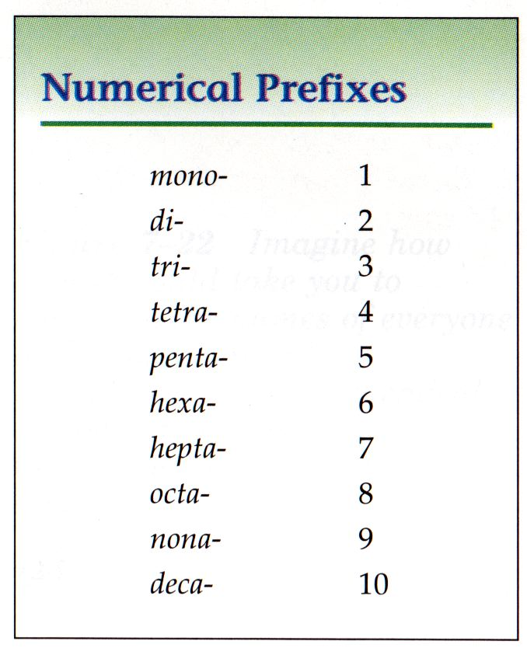

NC p185-6

- Common molecules that have non-systematic names:
Molecule name | Formula
ammonia | $${NH}_{3}$$
water | ${\text{H}}_{\text{2}}$O
hydrogen peroxide | $${\text{H}}_{\text{2}}{\text{O}}_{\text{2}}$$
ethanoic acid | $$\text{C}{\text{H}}_{\text{3}}\text{COOH}$$
hydrochloric acid | $$\text{HC}l$$
nitric acid | $$\text{HN}{\text{O}}_{\text{3}}$$
carbonic acid | $${\text{H}}_{\text{2}}\text{C}{\text{O}}_{\text{3}}$$
sulfuric acid | $${\text{H}}_{\text{2}}\text{S}{\text{O}}_{\text{4}}$$
sulfurous acid | $${\text{H}}_{\text{2}}\text{S}{\text{O}}_{\text{3}}$$
phosphoric acid | $${\text{H}}_{\text{3}}\text{P}{\text{O}}_{\text{4}}$$

PROBLEM SET #5:

Complete this table:

Molecular  Formula | Systematic  Name | Common  Name
CO
CO₂
N₂O
NO |  | Nitric oxide
NO₂
N₂O₄
SO₂
H₂O
H₂O₂
H₂S
HF
HCl
NH₃
CCl₄

NC p186 QS 3.6
EC p67-9 Set 14

Intramolecular and Intermolecular forces
- Intramolecular forces: The internal bonding that exists within compounds. These include covalent molecular substances –(e.g. iodine):
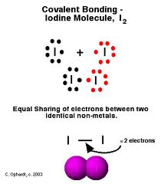
- Exist as directional electrostatic forces between the nuclei and the shared electron pairs.

- Large amount of energy is required to separate iodine molecules into individual atoms (break covalent bond):

I₂ _{(g)} → 2I _{(g)}

- Strong bonding forces exist between iodine atoms within the iodine molecules.

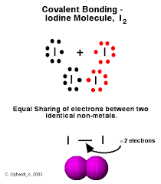


- Intermolecular forces: The external force that exists between molecules which is weak; indicated by low melting and boiling points.

Covalent Bonds and Valence Electrons

- The number of covalent bonds formed by an element depends on the number of electrons in its valence or outer energy level.

- The electron pairs forming the covalent bond are called bonding electron pairs.

- The remaining electron pairs which are not involved in the formation of covalent bonds are called non-bonding electrons pairs or lone pairs.

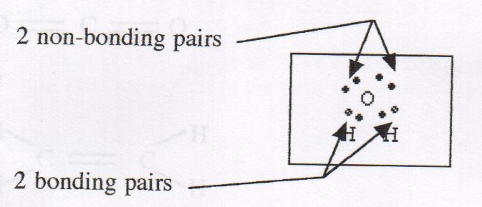
The number of bonding electrons pair and non-bonding electron pairs are shown below in the water molecule:

Molecular formulae represent the number and type of atoms present in the molecules.

Electron dot diagrams
- Electron dot diagrams (like below) are often used to illustrate covalent bonds. Shared electron pairs can also be represented with a line (Lewis diagrams).

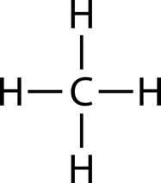
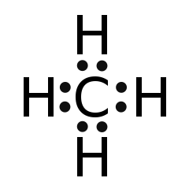


- Show the covalent bonds in the following compounds using an electron dot diagram:
Cl₂ H₂O CCl₄

Multiple Covalent Bonds

- A double covalent bond - a covalent bond in which there is two shared pairs of electrons:

i. each oxygen atom is two electrons short of a valence electron octet.
ii. each oxygen atom accepts a share in two electrons belong to the other oxygen atom.
iii. hence 4 electrons are shared by the two oxygen atoms and occupy the valence energy level of both.

- Show the double covalent bond in O₂ using a dot diagram and a Lewis diagram:
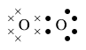
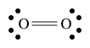

- The type of covalent bond that forms between nitrogen atoms is a triple covalent bond, since with nitrogen there are three valance electrons short of a valance electron octet.
- NOTE: In dot diagrams you can also use an ‘x’ to represent the electrons from other attached elements.

- Show the covalent bonds in N₂

- Complete a Lewis Diagram and an electron dot diagram for the following:

a. carbon dioxide b. ethene c. ethyne

NC p178-180
EC p59 Set 12

The properties of covalent network substances, including high melting point, hardness and electrical conductivity, are explained by modelling covalent networks as three-dimensional structures that comprise covalently bonded atoms.

Covalent Network Substances

- Substance such as diamond (C) and silica (SiO₂), consist of three dimensional network structures wherein all the atoms are linked together by strong covalent bonds.
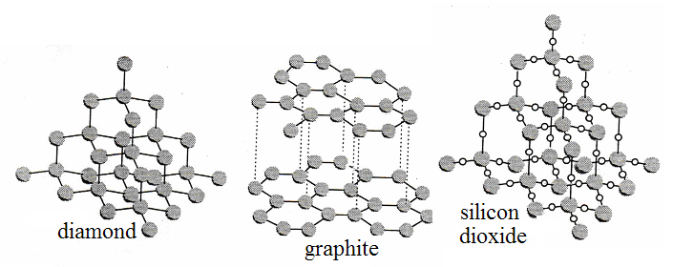
- These covalent bonds are continuous throughout the structure and results in a very hard structure with high boiling points.
- Covalent network substances have the following characteristic properties:

i. Very high melting and boiling points
ii. Non-conductors of electricity
iii. extremely hard and brittle
iv. chemically inert
v. insoluble in water and most other solvents.

- The properties listed above are the result of strong covalent bonding giving strength and high melting points. The highly localised electrons prevent the conduction of electricity, except for graphite which has one delocalised electron from each carbon atom.

NC p181-4
Elemental carbon exists as a range of allotropes, including graphite, diamond and fullerenes, with significantly different structures and physical properties.

Allotropes of carbon

- Allotropes of carbon are diamond, graphite and fullerenes.

- What is an allotrope?

- Read NC p181-182 and produce a summary about diamond, graphite and fullerenes.

DIAMOND
____________________________________________________________________________________________________________________________________________________________________________________________________________________________________________________________________________________________________________________________________________________________________________________________________________________________________________________________________________________________________________________________________________________________________________________________________________________________________________________________________________________________________________________________________________________________________________________________________________________________________________________________________
____________________________________________________________________________
GRAPHITE
____________________________________________________________________________________________________________________________________________________________________________________________________________________________________________________________________________________________________________________________________________________________________________________________________________________________________________________________________________________________________________________________________________________________________________________________________________________________________________________________________________________________________________________________________________________________________________________________________________________________________________________________________
____________________________________________________________________________
FULLERENES
____________________________________________________________________________________________________________________________________________________________________________________________________________________________________________________________________________________________________________________________________________________________________________________________________________________________________________________________________________________________________________________________________________________________________________________________________________________________________________________________________________________________________________________________________________________________________________________________________________________________________________________________________
____________________________________________________________________________________________________________________________________________________________________________________________________________________________________
EC p62 Set 13

BONDING: Summary

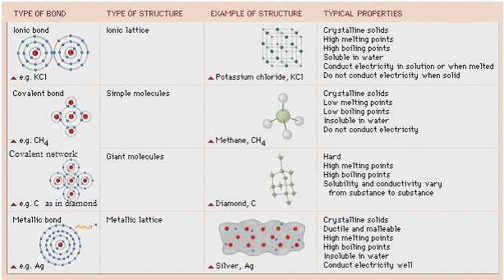
Diagram Ionic Bonding:

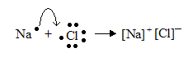

Diagram Covalent Bonding:

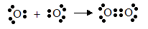

Ionic:

Structure | Properties
- formed from electrostatic attraction between two oppositely charged atoms  - basic particles which make up ionic compounds are ions: electrically charged atoms which have lost or gained electrons.  - exist between metallic and non-metallic ions  - form a regular lattice of ions  - valence electrons taken from one atom (metal) and kept mainly around other atom (non-metal.  - resulting electron configuration stable as each atom appears to have full outer shell. | - brittle as compounds containing ionic bonds are crystalline solids with every ion strongly bonded to its neighbours, and the whole is thus held in a rigid lattice with a specific shape.  - high melting and boiling points because the very strong bonding associated with ionic compounds means that much energy is required to break bonds.  - soluble in water because water is a so-called ionising solvent, because of polar nature.  - conducts electricity when in solution or molten because both solution and molten compound contain mobile ions which conduct electricity. Solid ionic compound cannot as ions held in their rigid lattice, and are not free to move.

Metallic
Structure | Properties
- outermost or valence electrons move about freely within a three-dimensional arrangement or lattice of positively charged metal ions.  - consists of positive ions surrounded by a ‘sea’ of electrons  - valance electrons are delocalised - not associated with a particular metal ion, move through the lattice of metal ions.  - negatively charged electrons attracted to positively charged metal ions in lattice - electrostatic attraction holds lattice together | - high densities indicate that the atoms are packed tightly together.  - malleability and ductility indicates limited resistance to movement of atoms with respect to each other.  - Electrical conductivity indicates that metal contain mobile charged particles.  - strength of metallic bond gives most metals high melting and boiling points.  - metals insoluble in water because they are incapable of bonding chemically with it.  - examples: zinc, copper, aluminium.

Covalent
Structure | Properties
- most compounds between non-metals  - atoms held together by electrostatic attraction between shared electrons and nuclei of adjacent atoms  - atoms combine to form molecules which share electrons so outer energy level has eight electrons – octet rule.  - single covalent bond formed when two atoms share a pair of valence electrons which allow each atom to acquire noble gas electron configuration | - molecules uncharged and electrons localised in covalent bonds, doesn’t contain ions so can’t conduct electricity  - molecules held together by strong covalent bonds but bonds between different molecules relatively weak, therefore easily broken.  - weak intermolecular bonds result in low boiling and melting points  - water is a polar molecule whereas many covalent molecular compounds are non-polar e.g. iodine. Only polar molecules dissolve in water

Covalent Network
Structure | Properties
- giant molecule with millions of covalent bonds  - consists of three dimensional network structure wherein all the atoms are linked together by strong covalent bonds.  - covalent bonds are continuous throughout the structure and result  - examples are diamond (C) and silica (SiO₂) | - hard – covalent bonds are continuous throughout the structure  - chemically inert  - high melting and boiling points – due to strong covalent bonds  - generally non-conductors (graphite exception) – most electrons fixed in bonds so prevents conductivity. Exception is graphite which has one delocalised election that can move so conduction occurs.  - usually insoluble in water due to many strong covalent bonds.
NC p187-8
PROBLEM SET #6

- Consider the following solids: A: metallic; B: Ionic; C: Covalent network ; D: Covalent molecular
Select the structure A, B, C, D most likely to show the following properties.
    - Silvery-grey solid that conducts electricity when solid and liquid. Melts at 660⁰C.
    - Brittle yellow solid melts at 113⁰C. Solid and liquid non-conductors.
    - Hard, brittle, white solid melts at 660⁰C. Solid non-conductor, liquid conductor.
    - Hard, white, crystalline solid melts at 1610⁰C. Solid and liquid non-conductors.
- Two Chlorides, XCl₂ and YCl₂. XCl₂ melting pt 772⁰C, boiling pt 1400⁰C. YCl₂ melting pt -23⁰C, boiling pt 76⁰C. What type of substance is each?

- Explain why molten KCl conducts an electric current but solid KCl does not.

- Identify the charged species which will conduct an electric current in the following:
• molten NaI • molten Cu
• solid Al • molten Mg(NO₃)₂
• a solution of Al(NO₃)₃
- Consider the following: CO₂, Zn, Al₂O₃, C, CH₄, brass, KF, I₂, Fe, SiO₂. Which are:
Ionic:
Metallic:
Covalent molecular:
Covalent network:
- Explain why metals are malleable while ionic solids are not.

- The melting points of the ionic solids sodium fluoride and magnesium oxide are 993ºC and 2852ºC respectively.
  - Identify the ions present in the two substances.
  - Both compounds have high melting points. What other physical properties do they have in common.

  - Explain the higher melting point of magnesium oxide compared to sodium fluoride.

- Describe what is meant by ionic bonding.

- List four properties of ionic solids and explain these properties using the ionic bonding model.

PROBLEM SET #7

- Write molecular formulas for the following:
Ammonia |  | Sulfur tetrafluoride
Nitrogen dioxide |  | Sulfur hexafluoride
Hydrogen sulfide |  | Dinitrogen pentoxide
Hydrogen peroxide |  | Nitrogen triodide

- Write names for the compounds represented by the following molecular formulas:
CO | CO₂
HF | CH₄
SO₃ | PCl₃
N₂O₃ | BrF₃

- Write formulas for the following:
a. zinc metal
b. molecular elements:
i. nitrogen
ii. sulphur
iii. phosphorous
iv. dinitrogen pentoxide
c. covalent network element: boron
Carbon
Silicon dioxide

d. Ionic compounds:
i. ammonium sulphide
ii. calcium sulphate-2-water
iii. aluminium sulphate
iv. magnesium nitride
4. Name the following substances:
a. N₂O₃
b. PCl₃
c. Mg(HSO₄)₂
d. Na₂CO₃.10H₂O
e. AuCN
f. NaHSO₃
5. Classify each of the following as an either an element or a compound:
N₂, He, C₂H₅OH, KI, C, NH₄NO₃ Cl₂

6. Name the 3 allotropes of carbon.

7. Classify the following substances as metals, ionic substances, covalent network substances or covalent molecular substances:

a. Substance A: Has a low melting point and a negligible conductivity in both the solid and molten states.
b. Substance B: Has a high melting point and a high conductivity in both the solid and
molten state.
c. Substance C: Has a high melting point. It does not conduct electricity in the solid state, but the molten state has high conductivity.
d. Substance D: Has a very high melting point and a negligible conductivity in both the solid and molten states.

8. Classify the following substances on the basis of their composition as metals, ionic substances or covalent molecular substances:
a. calcium oxide (CaO)
b. carbon dioxide (CO₂)
c. neon (Ne)
d. silver (Ag)
e. copper II chloride (CuCl₂)
f. mercury

PROBLEM SET #8

a. What is a covalent bond?

b. What forces are responsible for holding the atoms together in a simple molecule such as F₂?

  - What valence electron configuration does an atom usually attain when it combines with other atoms?

  - Why is this valence electron configuration generally stable?

  - Draw an electron dot diagram showing the bonding in F₂.

  - Identify the bonding and non-bonding pairs in F₂ in the above diagram.

  - Where are the bonding electrons in F₂ localised most of the time?

2. “In covalent molecular substance the force within molecules are strong but the force between molecules are weak.”

Explain what is meant by this statement, illustrating your answer with chlorine (Cl₂) which has a melting point of -101ºC but does not break into separate atoms except at very high temperatures.

3. List the properties of covalent molecular substances and give an explanation for each property.

4. A. Draw electron dot diagrams for the following substances:
- Br₂ d. HF

- CH₃OH e. PCl₃

- CCl₂F₂ f. CH₃CH₃

B. In the molecules HF, CH₃OH and Br₂ identify the bonding and non-bonding pairs.
C. Write formulas, using a straight line between atoms to represent a covalent bond for the molecules listed above.

5. How many electrons are shared in the formation of each of the following?
- a single covalent bond b. a double covalent bond
- a triple covalent bond
- Show the bonding in the following molecules using:
(i). electron dot notation, (ii).the straight line bond notation

a. HCN c. CS₂

b. C₂H₂ d. HCHO

7. Draw an electron dot diagram for the hydronium ion (H₃O⁺) and identify any covalent bonds, coordinate bonds and non-bonding electrons pairs. In this ion does the strength of the coordinate covalent bond differ from the other covalent bonds?

8. Draw electron dot diagrams for the following molecules and identify and single covalent bonds, double covalent bonds and coordinate covalent bonds.

a. N₂O c. SO₃

b. SO₂ d. CO

REVISON: Test on Atomic Structure and Bonding (allow 1 hour)

Part 1: MULTIPLE CHOICE (20 marks)

- Which of the following ions does not have the same electronic configuration as the rest? (Assume all ions are in their lowest energy state).

a) O²⁻
b) Mg²⁺
c) F⁻
d) K⁺

- Molten sodium chloride has a higher electrical conductivity than solid sodium chloride because in molten sodium chloride the
a) electrons are able to move more freely
b) electrostatic forces between the ions are much smaller
c) ions are significantly further apart
d) ions are able to move more freely

- Which of the following substances is most likely to be the best electrical conductor in the molten state?

a) potassium fluoride
b) magnesium chloride
c) aluminium bromide
d) sodium iodide

4. A characteristic of metallic elements is that
a) their atoms have only a small number of electrons in the valence shell and these can be removed relatively easily.
b) their valance electrons have high ionisation energies so are easily removed.
c) their atoms usually share electrons with atoms of non-metals.
- in the solid state electrostatic forces are not important since strong metallic bonds hold the atoms together.

5. Which of the following electron dot formulas is incorrect?
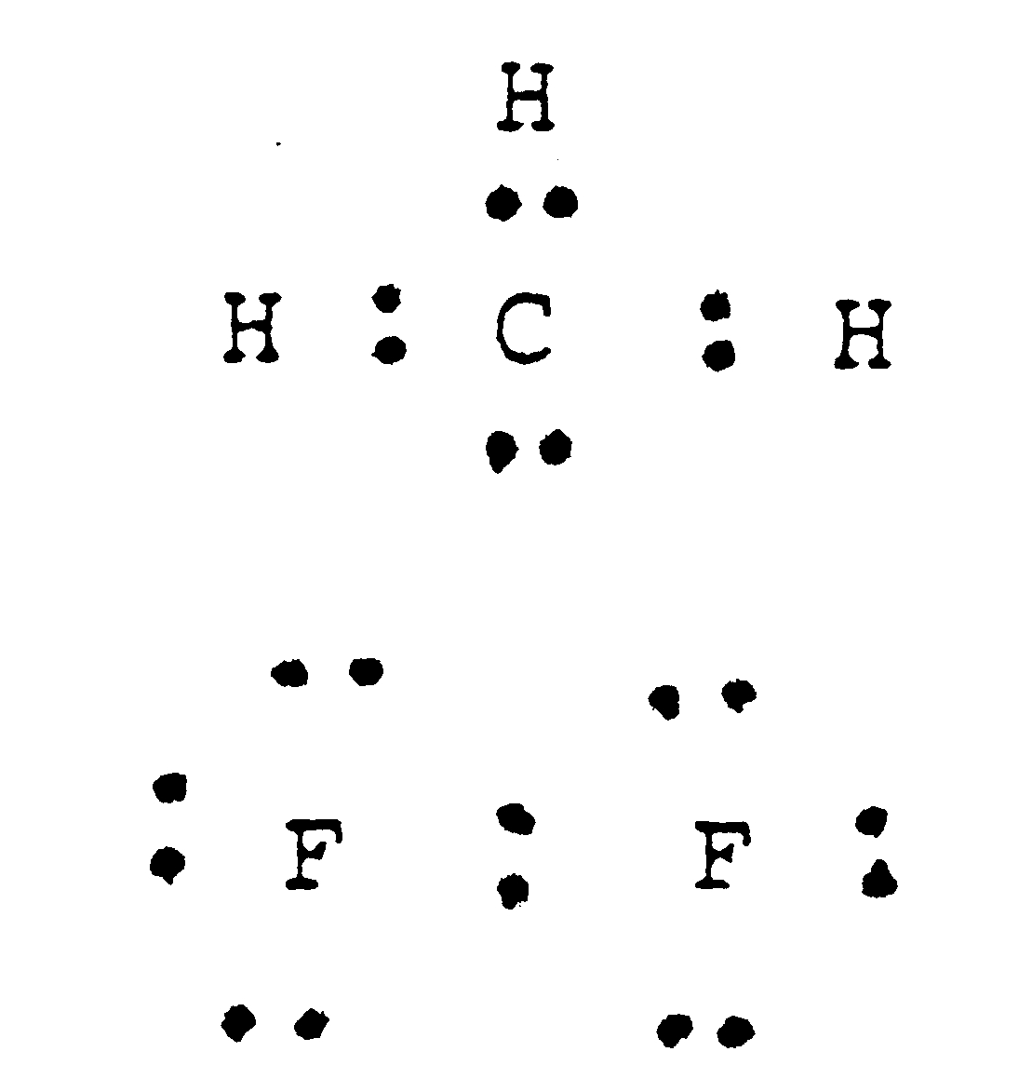

a) c)

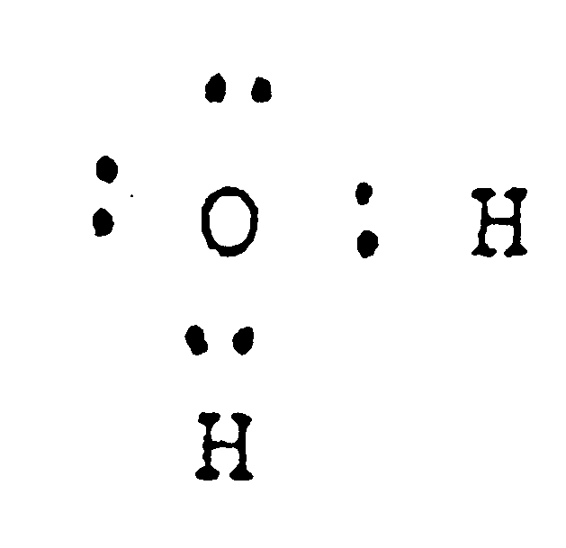

- d)

6. The number of lone pairs in a molecule of chlorine is

a) 3
b) 6
c) 4
d) 7

7. The number of bonding electron pairs in a molecule of nitrogen is

a) 1
b) 2
c) 3
d) 4

8. The formation of an ionic compound from a reaction between two elements involves:

- sharing of pairs of electrons between atoms.
- donation of valence electrons to the entire crystal lattice.
- transfer of electrons between atoms.
- ionization of the atoms of the more electronegative element.

9. The melting temperature of some common molecular substances are given below:

Substance Melting temperature/◦C
Br₂ -7
Cl₂ -101
N₂ 0₄ -10
HBr -85

Of the four substances listed, the one in which forces between the molecules are least is:

a) Br₂
b) Cl₂
c) N₂0₄
d) HBr

10. Which one of the following substances does not have strong bonds entering throughout the crystal?

a) Ca_{(s)}
b) KNO_{3(s)}
c) SiC_{(s)}
d) NH_{3(s)}

11. An ionic substance can be distinguished from metallic and molecular substances by measuring the electrical conductivity of the substance in

- the solid state only.
- the liquid state only.
- an aqueous solution only.
- the solid and liquid states.

12. Which of the following bond types are NOT electrostatic in nature?

- ionic bonds
- metallic bonds
- covalent bonds
- They are all electrostatic in nature

The next three items refer to the following information. Three solid substances were tested in three ways:
 | Test 1 | Test 2 | Test 3
 | Hit a small lump of the substance with a hammer | Place substance in a crucible and heat gently | Test some of the substance for electrical conductivity
Result for  substance I | flattened | melted easily | non-conductor in both the solid and liquid state
Result for  substance II | shattered | no visible change | non-conductor in the solid state: conducted electricity in the liquid state
Result for  substance III | shattered | melted easily | non-conductor in both the solid and liquid state

13. The most probable chemical structure for solid substance I is

- metallic lattice
- discrete (individual) molecules
- covalent network lattice
- ionic lattice

14. The most probable chemical structure for solid substance II is

- metallic lattice
- discrete (individual) molecules
- covalent network lattice
- ionic lattice

- The most probable chemical structure for solid substance III is

  - metallic lattice
  - discrete (individual) molecules
c) covalent network lattice
d) ionic lattice

- The physical properties of solid metals can best be explained by proposing that
  - each metal atom is bonded in the crystal lattice by covalent bonds.
  - positive metal ions are arranged in an orderly way, with valence electrons able to move freely through the crystal lattice.
  - positive and negative metal ions are arranged in an orderly way, with mobile valence electrons able to migrate easily around the crystal lattice.
  - each metal atom is surrounded by a variable number of valence electrons, which complete a “noble gas” electronic structure in the crystal lattice.

- Phosphorous is in the group V of the periodic table. The bonding in a P₂H₄ molecule would be best represented by the electron dot formula
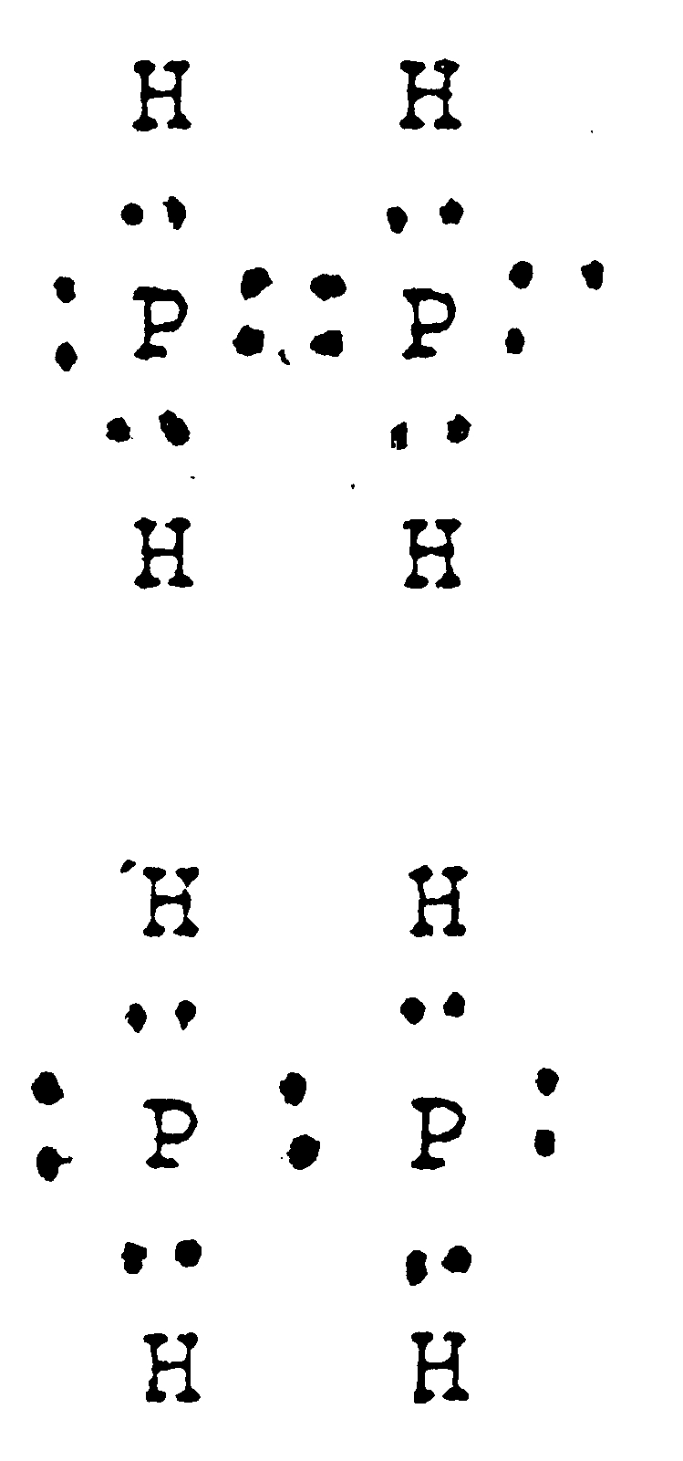
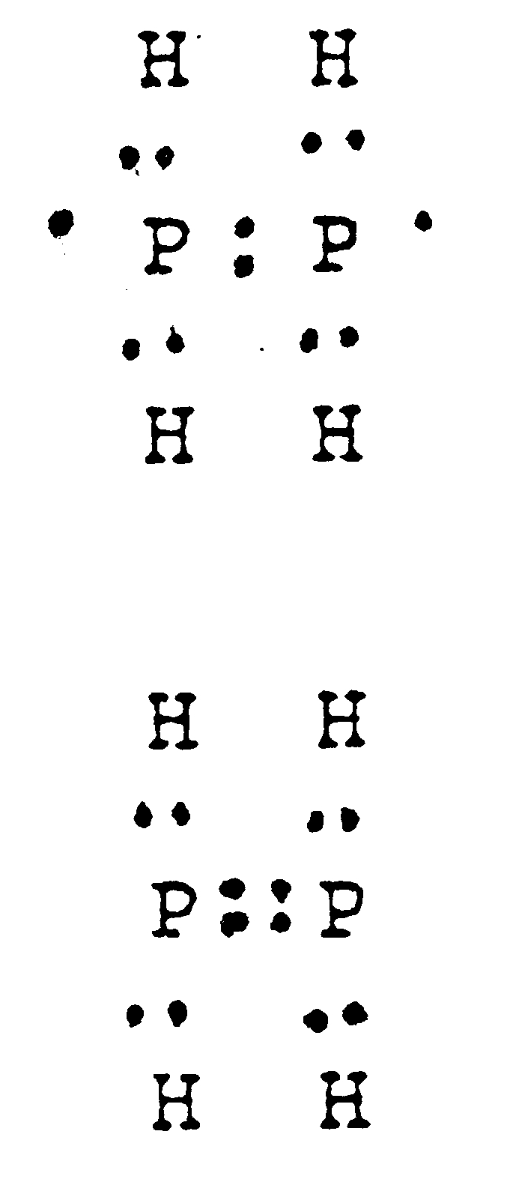

a) c)

b) d)

- Copper wire may be bent easily without breaking.
The best explanation of this is that:

a) slight changes in relative positions of adjacent copper particles do not
break the metallic bonds as these are equally strong in all directions.
b) the forces between copper atoms are weak, allowing the copper particles
to be easily moved around.
- copper particles are strongly bonded in layers but only weakly bonded
between layers.
- copper particles are arranged in flat molecules which freely slide over
each other, allowing the material to be bent.

WRITTEN SECTION (22 marks)

1. Draw electron dot structure to illustrate the bonds formed in the following compounds: (3 marks)

- MgO

- CH₃C1

- HCN

2. Explain WHY solutions of ionic substances are able to conduct electricity. (2 marks)

(2 marks)
3. Write the electron configuration for: (3 marks)

- a neutral sodium atom:___________________________________

- a neutral sulfur atom:____________________________________

- a sulfide ion: __________________________________________

4. Complete the table below: (5 marks)

ELEMENT NAME | SYMBOL | N^{O}. OF PROTONS | N^{O}. OF NEUTRONS | MASS N^{O}. | ATOMIC N^{O}.
SILVER
URANIUM |  | 92 |  | 235
OXYGEN |  | 8 | 9
 |  |  |  | 207 | 82

5. What is the valency of X in the following? (2 marks)
  - X₂O __________________________________________
b) XCl₃ __________________________________________
c) H₂X __________________________________________
d) CaX₂ _______________________________________________________________
6. Write formulae for the following compounds: (4 marks)
- potassium sulphate __________________________________________
- magnesium chloride __________________________________________
- aluminium oxide __________________________________________
- ammonium hydroxide __________________________________________
- sodium nitrate __________________________________________
- sulfuric acid __________________________________________
- carbon monoxide __________________________________________
- carbon tetrachloride __________________________________________
7. Name the following substances: (3 marks)
- PCl₅ __________________________________________
- N₂0₄ __________________________________________
- CO₂ __________________________________________
- Al₂(SO₄)₃ __________________________________________
- CuSO_{4 .} 5H₂O __________________________________________
- NH₄Br __________________________________________

ANSWERS

MULTIPLE CHOICE ANSWER SHEET
11. [A] [B] [C] [D]

12. [A] [B] [C] [D]

13. [A] [B] [C] [D]

14. [A] [B] [C] [D]

15. [A] [B] [C] [D]

16. [A] [B] [C] [D]

17. [A] [B] [C] [D]

18. [A] [B] [C] [D]

1. [A] [B] [C] [D]

2. [A] [B] [C] [D]

3. [A] [B] [C] [D]

4. [A] [B] [C] [D]

5. [A] [B] [C] [D]

6. [A] [B] [C] [D]

7. [A] [B] [C] [D]

8. [A] [B] [C] [D]

9. [A] [B] [C] [D]

10. [A] [B] [C] [D]

WRITTEN SECTION (22 marks)

1. Draw electron dot structure to illustrate the bonds formed in the following compounds:
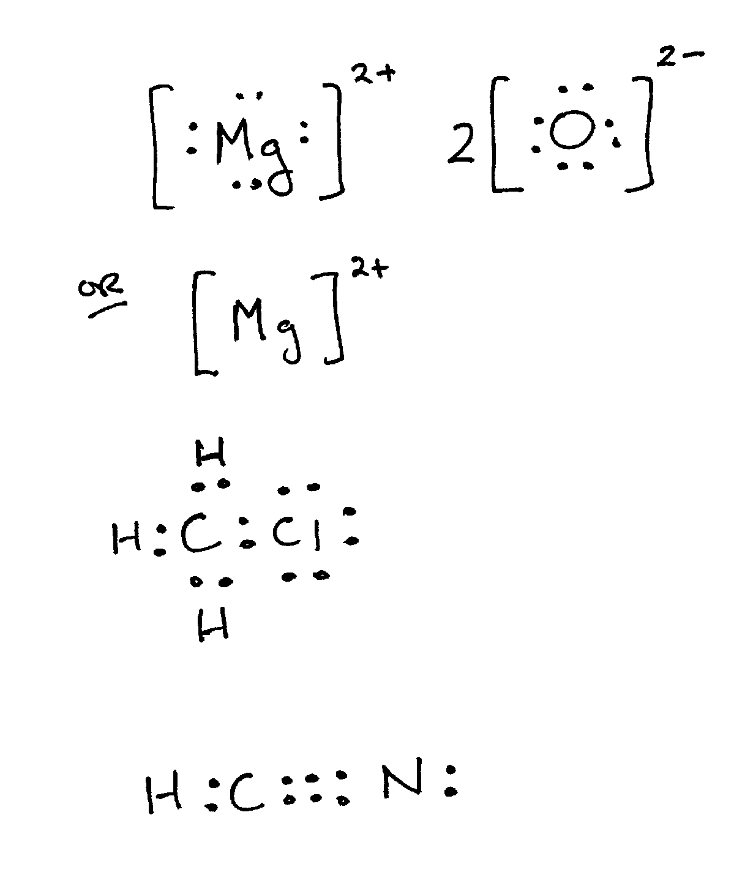

- MgO

- CH₃C1

- HCN

(3 marks)

2. Explain WHY solutions of ionic substances are able to conduct electricity.

Ions (positive and negative) are free to move and hence charge can move.

(2 marks)
3. Write the electron configuration for:

- a neutral sodium atom: 281

- a neutral sulfur atom: 286

- a sulfide ion: 288

(3 marks)
4. Complete the table below:

ELEMENT NAME | SYMBOL | N^{O}. OF PROTONS | N^{O}. OF NEUTRONS | MASS N^{O}. | ATOMIC N^{O}.
SILVER | 107  Ag  47 | 47 | 60 | 107 | 47
 | 7  Li  3 | 3 | 4 | 7 | 3
URANIUM | 235  U  92 | 92 | 143 | 235 | 92
OXYGEN | 17  O  8 | 8 | 9 | 17 | 8
LEAD | 125  Pb  82 | 82 | 125 | 207 | 82

(5 marks)

5. What is the valency of X in the following?

  - X₂O +1

b) XCl₃ +3

c) H₂X -2

d) CaX₂ -1

(2 marks)

6. Write formulae for the following compounds:

- potassium sulphate K₂SO₄

- magnesium chloride MgCl₂

- aluminium oxide Al₂O₃

- ammonium hydroxide NH₄OH

- sodium nitrate NaNO₃

- sulfuric acid H₂SO₄

- carbon monoxide CO

- carbon tetrachloride CCl₄

(4 marks)

7. Name the following substances:

- PCl₅ Phosphorous pentachloride

- N₂0₄ Dinitrogen tetroxide

- CO₂ Carbon dioxide

- Al₂(SO₄)₃ Aluminium sulfate

- CuSO_{4 .} 5H₂O Copper II carbonate 5 water

- NH₄Br Ammonium bromide

(3 marks)

END OF TEST TOTAL: 40 marks.

PROBLEM SET #1:

- For an element to be a metal what is the major characteristic of the valence electrons of the element?
Low ionisation energies – easily removed - become delocalised electrons
- List four properties of metals and show how these properties can be explained in terms of the ‘delocalised electrons’ model of metallic bonding.
  - Good conductors of heat – mobile electrons transfer heat
  - Good conductors of electricity – mobile electrons transfer charge
  - Malleable and ductile – metallic bonds non-directional
  - High melting and boiling points – strong electrostatic attraction between the positive metal ions and delocalised electrons

- Mercury has a melting point of -38.9 ºC and tungsten has a melting point of 3410 ºC. What does this indicate about the metallic bond?

Strength of metallic bond varies quite a bit

- Explain why:
- copper is used in wiring a house
- titanium is used in the production of airplanes.
  - Copper – Excellent conductor of electricity
Cheap, Excellent ductility, Can’t rust

  - Titanium – light weight
Very high tensile strength, Can’t rust
High lustre, Excellent malleability

PROBLEM SET #2:

Why will a magnesium sulphate crystal shatter when you hit it with a hammer but magnesium will not? Explain fully. (Use diagrams to assist you)

Strong directional attractive force exists between oppositely charged ions (Mg²⁺ and SO₄²⁻)

If a layer of a magnesium sulfate crystal is hit and forced to slide past another layer, the orderly arrangement of ions is disturbed.

Ions of similar charge are forced closer to another with an increase in repulsive forces and decrease in attractive forces - the MgSO₄ crystal fractures.



- If we have a formula PQ₃ and the electronic configuration of both ions is 2,8 then what are the possible identities of P and Q?
P would probably be from group 13 (loses 3 e⁻) and row 3 – removed its 3rd shell = Al.
Q would be from group 17 (gains 1e⁻) and row 2 – fills its 2nd shell = F.

- If the formula of a simple salt made up of just two elements is JX₂ and the ions have the same electron population of Argon then what are the possible identities of J and X?

J = Ca and X = Cl.

- Krypton has the same electron configuration as both ions in an ionic substance whose identity is hidden in a general formula ZD. What are THREE possible element combinations that agree with this formula ratio?

Kr = 2 8 8 18. Ionic substances need to be +1/-1, +2/-2 and +3/-3 from Kr.
I.e. Rb Br, Sr Se, Y and As.

- What is the identity of the two elements in ionic substance RA₃ where the metallic element is like neon in its electronic configuration and the non-metal ion is like Krypton?

R = +3 (Al) and A = -1 (Br) = Al Br₃.
- What is the identity of the elements in GL if the cation has electron population 2 8 8 and the element L has electron population 2 8 6 ?

G = calcium, L = sulphur Ca S.

6. Explain why in potassium chloride there must be the same number of potassium ions and chloride ions whereas in magnesium chloride there are twice as many chloride ions as magnesium ions.

To make a neutral compound, the number of positive charges must equal the number of negative charges.
With KCl, the respective charges are +1 and -1 so K and Cl combine in the ration of 1:1 to create a neutral compound.
However, with MgCl₂ the Mg has a 2+ charge so must combine with Cl in the ratio of 1:2 to create a neutral compound.

PROBLEM SET #4:
- Why does a covalent molecular substance not conduct electricity?

- Free electrons or ions are required to conduct electricity.
- Molecular covalent substances consist of molecules where all electrons experience directional electrostatic forces of attractions.
- No free electrons available – no conduction of electricity

- Why does sulphur (S₈) melt at 115.2 °C and carborundum (SiC) at 2730 °C? Explain fully.
- Sulfur is a covalent molecular substance.
- The molecule is held together by a strong intramolecular bond (covalent bond) where the electrostatic force of attraction between the shared electrons and the adjacent nuclei hold the molecule together.
- The molecules experience weak intermolecular forces between the molecules which require a small amount of energy to break this bond – low melting point (115.2 °C)
- Carborundum is a covalent network substance.
- The network is held together by a strong intramolecular bond (covalent bond) where the electrostatic force of attraction between the shared electrons and the adjacent nuclei hold the network together.
- There are no weak intermolecular forces and therefore it requires a large amount of energy to break this covalent bond – high melting point (2730 °C)

- Name four properties of covalent network substances.
Very high melting and boiling points
Non-conductors of electricity
Extremely hard and brittle
Chemically inert
Insoluble in water and most other solvents.

PROBLEM SET #5:

Molecular  Formula | Systematic  Name | Common  Name
CO | carbon monoxide
CO₂ | carbon dioxide
N₂O | dinitrogen monoxide | Nitrous oxide(laughing gas)
NO | nitrogen monoxide | Nitric oxide
NO₂ | nitrogen dioxide
N₂O₄ | dinitrogen tetroxide
SO₂ | sulphur dioxide
H₂O | dihydrogen monoxide | Water
H₂O₂ | dihydrogen dioxide | Hydrogen peroxide
H₂S | dihydrogen sulfide | Hydrogen sulphide
HF | hydrogen fluoride | Hydrofluoric acid
HCl | hydrogem chloride | Hydrochloric acid
NH₃ | nitrogen trihydride | Ammonia
CCl₄ | carbon tetrachloride | Tetrachloro methane

PROBLEM SET #6

- Consider the following solids: A: metallic; B: Ionic; C: Covalent network ; D: Covalent molecular
Select the structure A, B, C, D most likely to show the following properties.
    - Silvery-grey solid that conducts electricity when solid and liquid. Melts at 660⁰C. A
    - Brittle yellow solid melts at 113⁰C. Solid and liquid non-conductors. D
    - Hard, brittle, white solid melts at 660⁰C. Solid non-conductor, liquid conductor. B
    - Hard, white, crystalline solid melts at 1610⁰C. Solid and liquid non-conductors. C
- Two Chlorides, XCl₂ and YCl₂. XCl₂ melting pt 772⁰C, boiling pt 1400⁰C. YCl₂ melting pt -23⁰C, boiling pt 76⁰C. What type of substance is each? XCl₂ Ionic YCl₂ covalent molecular
- Explain why molten KCl conducts an electric current but solid KCl does not.
In molten state, K⁺ and Cl⁻ ions are mobile whereas in solid KCl they are not.

- Identify the charged species which will conduct an electric current in the following:
• molten NaI Na⁺ I⁻ • molten Cu electrons
• solid Al electrons • molten Mg(NO₃)₂ Mg²⁺ NO₃⁻
• a solution of Al(NO₃)₃ Al³⁺ NO₃⁻
- Consider the following: CO₂, Zn, Al₂O₃, C, CH₄, brass, KF, I₂, Fe, SiO₂. Which are:
Ionic: Al₂O₃ KF
Metallic: Zn brass Fe
Covalent molecular: CO₂ CH₄ I₂
Covalent network: C SiO₂
- Explain why metals are malleable while ionic solids are not.
Metallic are malleable because metallic bonds are non-directional and the lattice structure can be deformed without disrupting the metallic bonds. When ionic crystals are distorted, similarly charged ions are brought close to each other and the crystal fractures.

- The melting points of the ionic solids sodium fluoride and magnesium oxide are 993ºC and 2852ºC respectively.
  - Identify the ions present in the two substances. Na⁺ F⁻ Mg²⁺ O²⁻
  - Both compounds have high melting points. What other physical properties do they have in common.
Both are hard and brittle:
Both are non-conductors when solid yet will conduct electricity in the molten state
  - Explain the higher melting point of magnesium oxide compared to sodium fluoride.
The magnesium oxide lattice contains doubly charged ions leading to a stronger electrostatic attraction between the ions and hence higher boiling points
- Describe what is meant by ionic bonding.
Ionic bonding is the electrostatic attraction between oppositely charged ions

- List four properties of ionic solids and explain these properties using the ionic bonding model.
- Hard and brittle – ions tightly bound by strong electrostatic attraction
- Non-conductors when solid – ions occupy fixed positions in the lattice, as no movement, can’t conduct electricity.
- Conduct when molten or in aqueous solution – mobile ions transfer charge so conduct electricity
- High melting and boiling points – ions tightly bound by strong electrostatic forces

PROBLEM SET #7

- Write molecular formulas for the following:
Ammonia | NH₃ | Sulfur tetrafluoride | SF₄
Nitrogen dioxide | NO₂ | Sulfur hexafluoride | SF₆
Hydrogen sulfide | H₂S | Dinitrogen pentoxide | N₂O₅
Hydrogen peroxide | H₂O₂ | Nitrogen triodide | NI₃

- Write names for the compounds represented by the following molecular formulas:
CO carbon monoxide | CO₂ carbon dioxide
HF hydrogen monofluoride | CH₄ carbon tetrahydride (methane)
SO₃ sulfur trioxide | PCl₃ phosphorous trichloride
N₂O₃ dinitrogen trioxide | BrF₃ bromine trifluoride

- Write formulas for the following:
a. zinc metal Zn
b. molecular elements:
i. nitrogen N₂
ii. sulphur S₈
iii. phosphorous PCl₅
iv. dinitrogen pentoxide N₂O₅
c. covalent network element: boron B
Carbon C
Silicon dioxide SiO₂

d. Ionic compounds:
i. ammonium sulphide (NH₄)₂S
ii. calcium sulphate-2-water CaSO₄.2H₂O
iii. aluminium sulphate Al₂(SO₄)₃
iv. magnesium nitride Mg₃N₂
4. Name the following substances:
a. N₂O₃ dinitrogen trioxide
b. PCl₃ phosphorous trichloride
c. Mg(HSO₄)₂ magnesium hydrogen sulfate
d. Na₂CO₃.10H₂O sodium carbonate-10-water
e. AuCN gold (I) cyanide
f. NaHSO₃ sodium hydrogen sulfite
5. Classify each of the following as an either an element or a compound:
N₂, He, C₂H₅OH, KI, C, NH₄NO₃ Cl₂
E E C C E C E
6. Name the 3 allotropes of carbon.
Graphite, diamond, buckyballs
7. Classify the following substances as metals, ionic substances, covalent network substances or covalent molecular substances:

a. Substance A: Has a low melting point and a negligible conductivity in both the solid and molten states. Covalent molecular
b. Substance B: Has a high melting point and a high conductivity in both the solid and molten
state. metal
c. Substance C: Has a high melting point. It does not conduct electricity in the solid state, but the molten state has high conductivity. Ionic compound
d. Substance D: Has a very high melting point and a negligible conductivity in both the solid and molten states. Covalent network

8. Classify the following substances on the basis of their composition as metals, ionic substances or covalent molecular substances:
a. calcium oxide (CaO) ionic
b. carbon dioxide (CO₂) covalent molecular
c. neon (Ne) element
d. silver (Ag) metal
e. copper II chloride (CuCl₂) ionic
f. mercury metal
PROBLEM SET #8

a. What is a covalent bond? Bonds in which adjacent atoms share electrons. Electrostatic
attraction such that atoms share electrons between nuclei.
  - What forces are responsible for holding the atoms together in a simple molecule such as F₂?
Electrostatic attraction between shared pair of electrons and nuclei of atom
  - What valence electron configuration does an atom usually attain when it combines with other atoms? An octet – eight valence electrons. Common exception is hydrogen.
  - Why is this valence electron configuration generally stable? It represent the electron configuration of noble gas with complete s and p subshells.
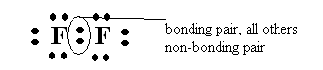
  - Draw an electron dot diagram showing the bonding in F₂.

- Identify the bonding and non-bonding pairs in F₂ in the above diagram. .
- Where are the bonding electrons in F₂ localised most of the time?
The bonding electrons are located between the two nuclei most of the time.
2. “In covalent molecular substance the force within molecules are strong but the force between molecules are weak.”

Explain what is meant by this statement, illustrating your answer with chlorine (Cl₂) which has a melting point of -101ºC but does not break into separate atoms except at very high temperatures.

COVALENT BONDING. Two kinds of forces. Covalent bonds – forces of attraction within molecules which hold atoms together. Intermolecular forces – force of attraction between molecules which hold atoms together.
In chlorine attractive forces between chlorine molecules in solid state are weak as indicated by the low melting point. However, the forces which hold the two chlorine atoms together as a chlorine molecule are very strong as indicated by the high temperature required to separate the atoms.
3. List the properties of covalent molecular substances and give an explanation for each property.
  - Low melting and boiling points – forces between molecules are weak so little energy is required to break bonds.
  - Non-conductors of electricity in the solid and molten state – molecules are uncharged and electrons are localised so unavailable to conduct electricity.
  - Solids are generally soft – forces between molecules are weak.
Check with your teacher for answers for most of the questions that follow for set 8.
4. A. Draw electron dot diagrams for the following substances:
- Br₂ d. HF
- CH₃OH e. PCl₃
- CCl₂F₂ f. CH₃CH₃
B. In the molecules HF, CH₃OH and Br₂ identify the bonding and non-bonding pairs.
C. Write formulas, using a straight line between atoms to represent a covalent bond for the molecules listed above.
5. How many electrons are shared in the formation of each of the following?
- a single covalent bond Two b. a double covalent bond Four
- a triple covalent bond Six
- Show the bonding in the following molecules using:
(i). electron dot notation, (ii).the straight line bond notation
a. HCN c. CS₂

b. C₂H₂ d. HCHO
7. Draw an electron dot diagram for the hydronium ion (H₃O⁺) and identify any covalent bonds, coordinate bonds and non-bonding electrons pairs. In this ion does the strength of the coordinate covalent bond differ from the other covalent bonds?
Covalent bonds
Coordinate bonds non-bonding pair

8. Draw electron dot diagrams for the following molecules and identify and single covalent bonds, double covalent bonds and coordinate covalent bonds.

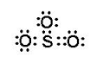
a. N₂O c. SO₃
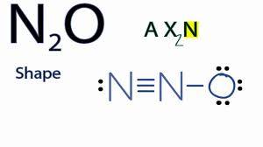


b. SO₂ d. CO
